VCS Task
Task Description:
Establish a new directory, populate it with script files, initiate an empty repository on GitHub, convert the local directory into a Git repository, and link it to GitHub for pushing the code into the repository.Perform merge, rebase, stash commands in following github repo.
Techstacks needs to be used :
- Shell (AWS, WSL, Vbox)
- Git (Gitbash)

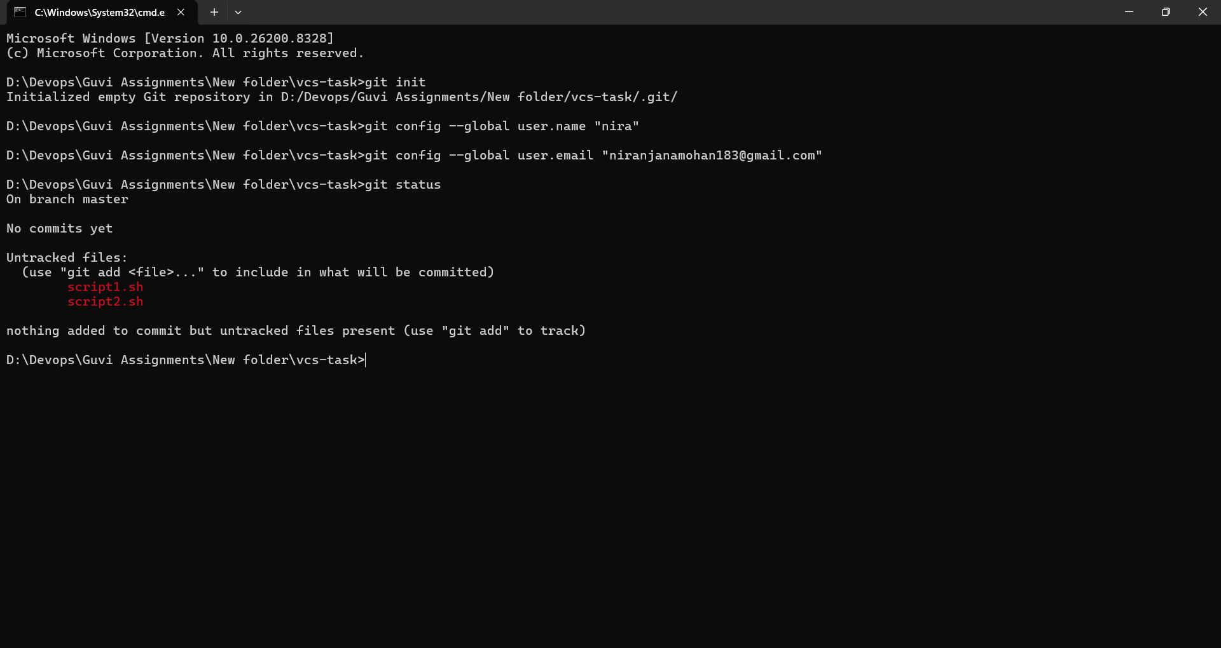

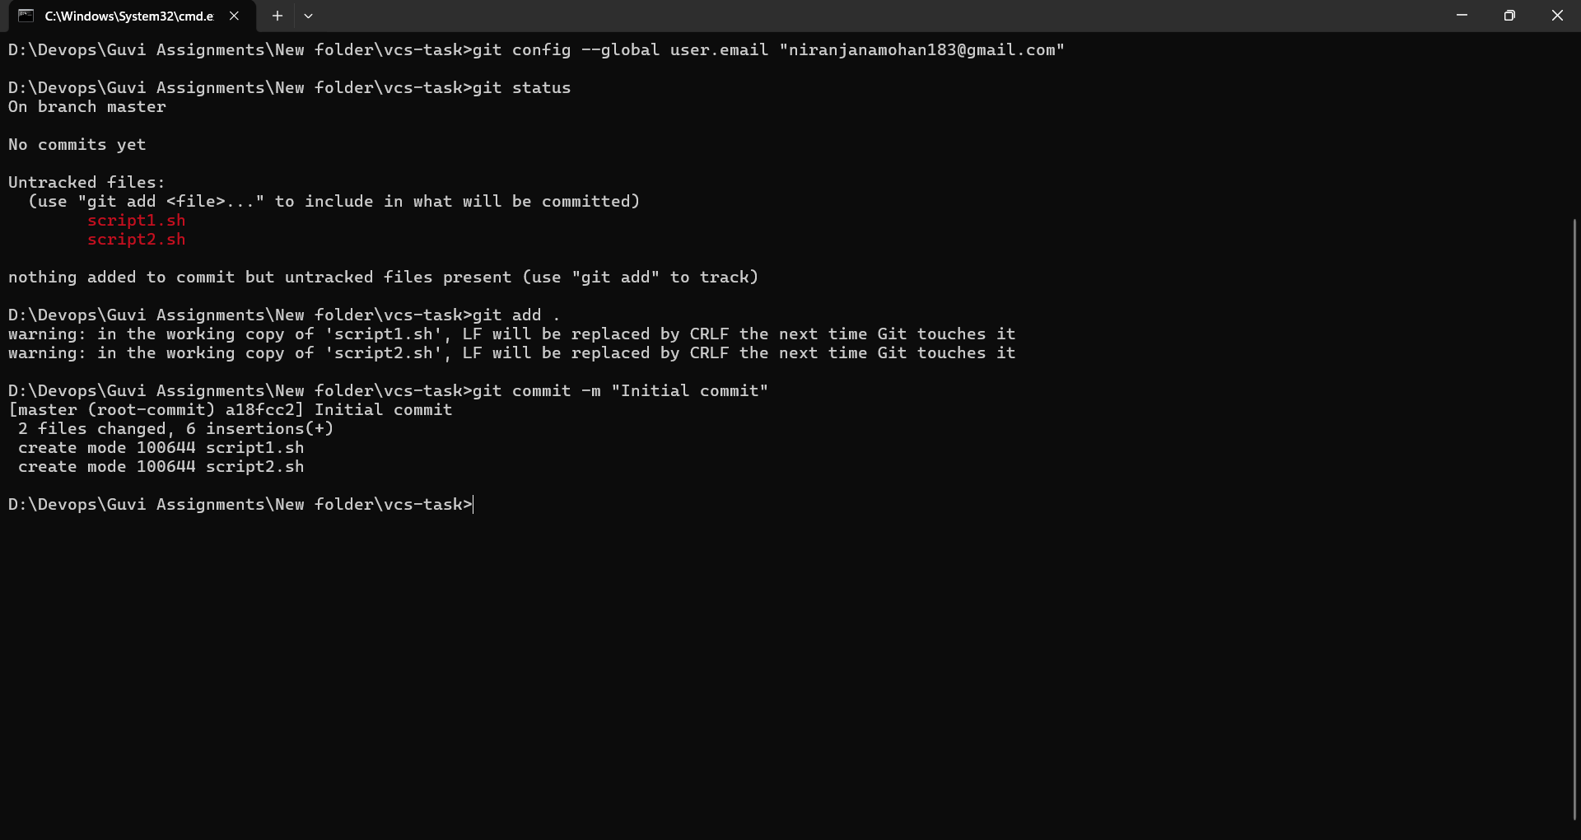

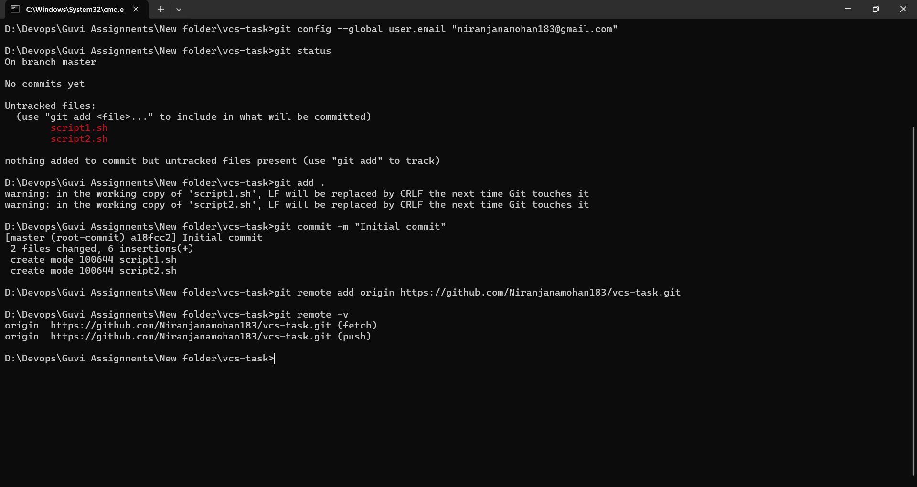

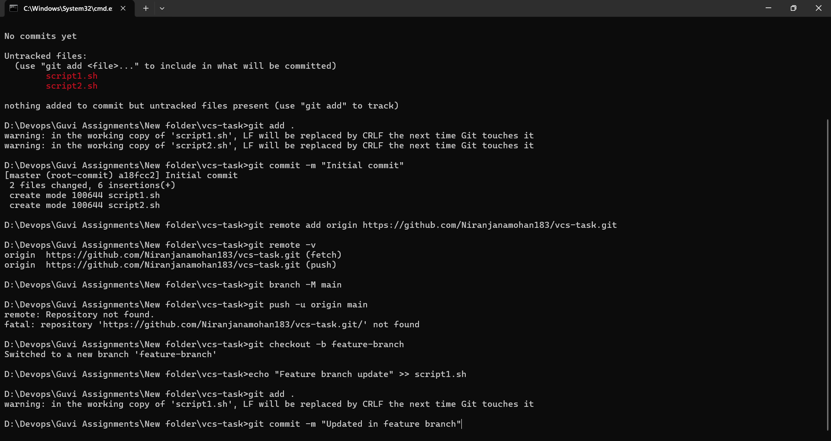

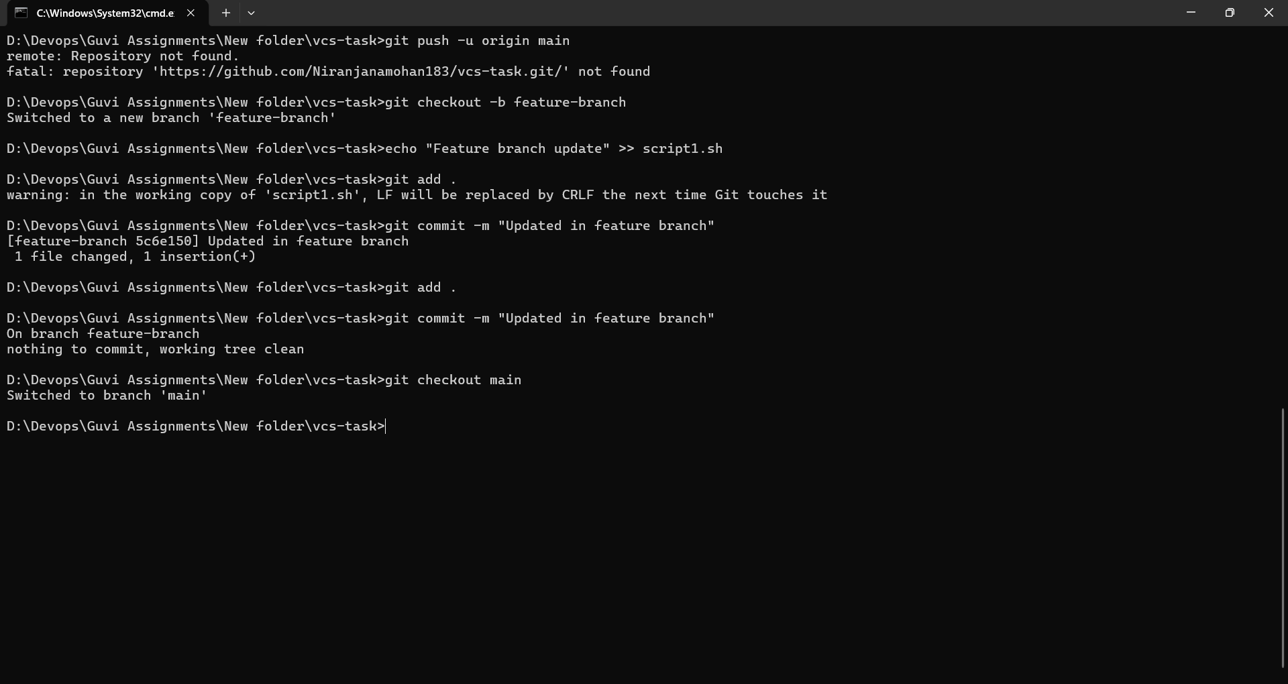

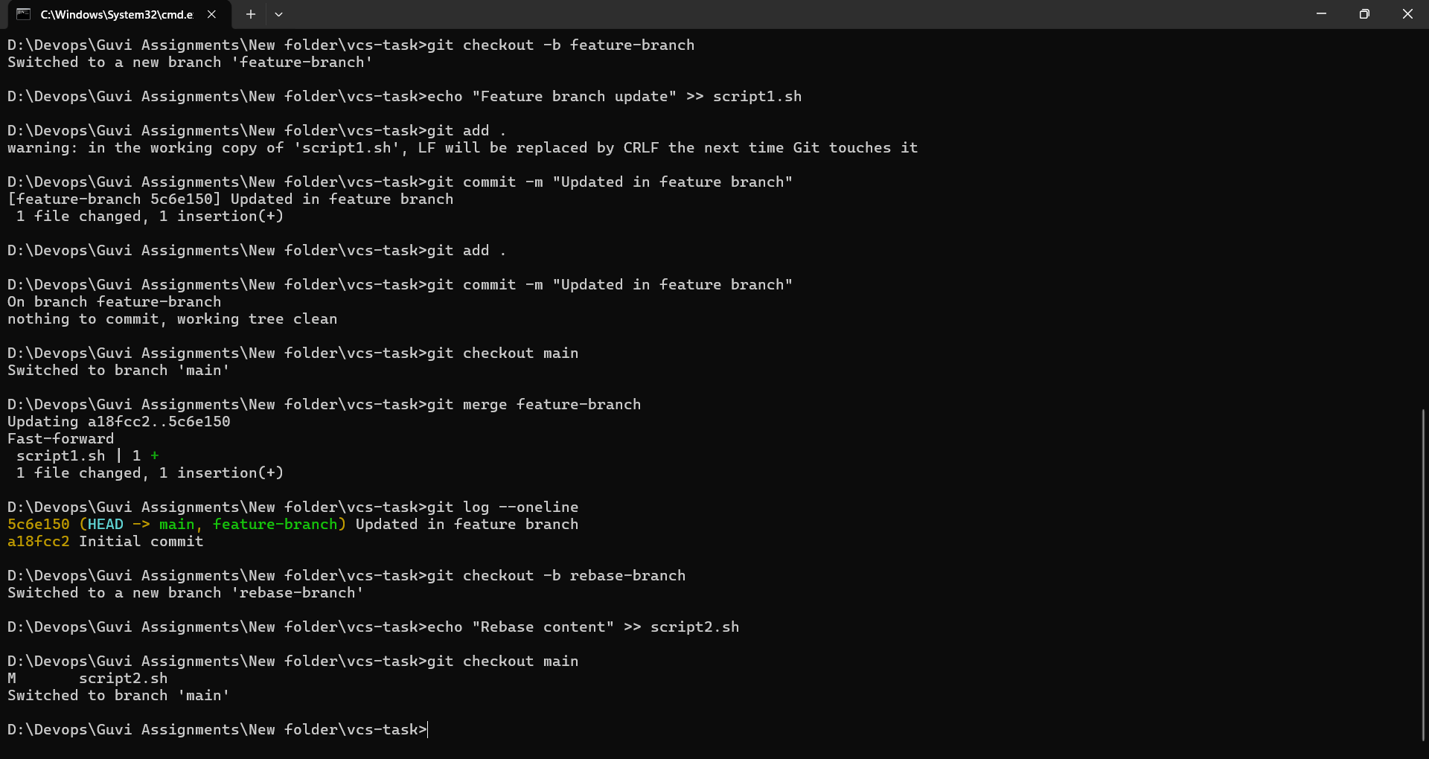

Command | Purpose
git init | Initialize repository
git add . | Stage files
git commit | Save changes
git push | Upload to GitHub
git pull | Download latest changes
git merge | Combine branches
git rebase | Reapply commits on another base
git stash | Temporarily save changes
Merge | Rebase
Preserves history | Creates cleaner history
Adds merge commit | No extra merge commit
Safer for teams | Better for linear history

